**EXPERIMENT 5**

**Aim :**

**(a)** Write a Program in C/C++ to compute previous date, given the present date as input and perform data flow testing.

1. Algorithm
2. Define/Use Table
3. Du Path Table
4. All uses-definition clear
5. Test case table of all uses
6. Test case table of all definition

**Algorithm :**

* Take 3 inputs from the user for Day, Month and Year.
* Check whether they lie in the given intervals.
* If the condition is false, stop the program and exit.
* If the condition is true, calculate the date according to the given values.
* Subtract 1 day from it to get the Previous Date.

**Code :**

#include <iostream>

using namespace std;

int main()

{ int d, m, y;

    cout << "Enter the Day, Month and Year (d, m, y) : ";

    cin >> d >> m >> y;

    if (d != 1)

    { if ((m == 2 || m == 4 || m == 6 || m == 9 || m == 11) & (d == 31))

            cout << "Invalid Date";

        else if ((m == 2) & (d == 30))

            cout << "Invalid Date";

        else if ((m == 2) & (d == 29) & (y % 4 != 0))

            cout << "Invalid Date";

        else

        cout << "Previous Date : " << d - 1 << "-" << m << "-" << y; }

    else

    {

        if (m == 3)

        {

            if (y % 4 == 0)

                d = 29;

            else

                d = 28;

        }

        cout << "Previous Date : " << d << "-" << m - 1 << "-" << y;

    }

    return 0;

}

**Output Screenshots :**

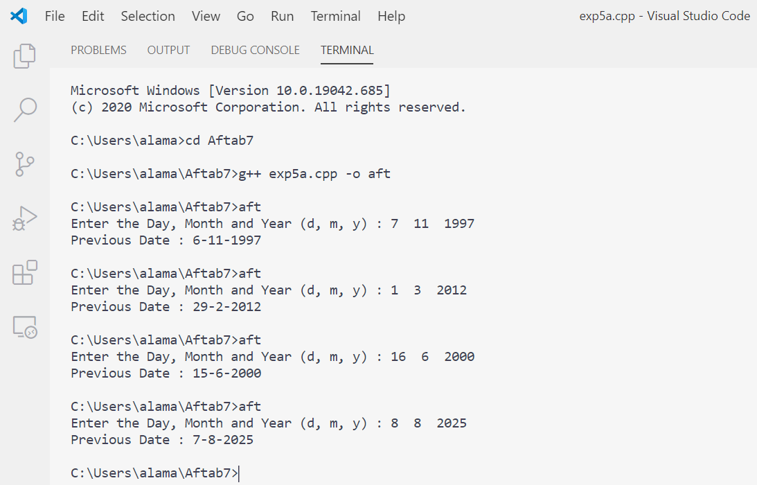

**Define/Use Table :**

|  |  |  |  |
| --- | --- | --- | --- |
| **S. No.** | **Variable** | **Defined at Node** | **Used at Node** |
| 1 | D | 3,16,20,22,25,29,32,36 | 5,10,13,36,38 |
| 2 | M | 3,17,23,26,30,33 | 7,10.15,17,18,23,24,28,30,33,38 |
| 3 | Y | 3,27 | 9,10,19,27,38 |

**Du Path Table :**

|  |  |  |  |  |
| --- | --- | --- | --- | --- |
| **S. No.** | **Variable** | **Du Path (Begin, End)** | | |
| 1 | D | 3,5  3,10  3,13  3,36  3,38  22,5  22,10  22,13  22,36  22,38  32,5  32,10  32,13 | 16,5  16,10  16,13  16,36  16,38  25,5  25,10  25,13  25,36  25,38  32,36  32,38  36,5 | 20,5  20,10  20,13  20,36  20,38  29,5  29,10  29,13  29,36  29,38  36,10  36,13  36,36  36,38 |
| 2 | M | 3, 7  3,10  3,15  3,17  3,18  3,23  3,24  3,28  3,30  3,33  3,38  26, 7  26,10  26,15  26,17  26,18  26,23  26,24  26,28  26,30  26,33  26,38 | 17, 7  17,10  17,15  17,17  17,18  17,23  17,24  17,28  17,30  17,33  17,38  30, 7  30,10  30,15  30,17  30,18  30,23  30,24  30,28  30,30  30,33  30,38 | 23, 7  23,10  23,15  23,17  23,18  23,23  23,24  23,28  23,30  23,33  23,38  33, 7  33,10  33,15  33,17  33,18  33,23  33,24  33,28  33,30  33,33  33,38 |
| 3 | Y | 3,9  3,10  3,19 | 3,27  3,38  27,9 | 27,10  27,19  27,27  27,38 |

**All uses-definition clear :**

|  |  |  |  |
| --- | --- | --- | --- |
| **S. No.** | **Variable** | **Du Path (Begin, End)** | **Definition clear?** |
| 1 | D | 3,5 | Yes |
| 2 | D | 3,10 | Yes |
| 3 | D | 3,10,13 | Yes |
| 4 | D | 3,10,13,36 | No |
| 5 | D | 3,10,13,36,38 | No |
| 6 | D | (16,5), (16,10), (16,13), (16,36) | Not Possible |
| 7 | D | 16,17,38 | Yes |
| 8 | D | (20,5), (20,10), (20,13), (20,36) | Not Possible |
| 9 | D | 20,23,38 | Yes |
| 10 | D | (22,5), (22,10), (22,13), (22,36) | Not Possible |
| 11 | D | 22,23,38 | Yes |
| 12 | D | (25,5), (25,10), (25,13), (25,36) | Not Possible |
| 13 | D | 25,26,27,38 | Yes |
| 14 | D | (29,5), (29,10), (29,13), (29,36) | Not Possible |
| 15 | D | 29,30,38 | Yes |
| 16 | D | (32,5), (32,10), (32,13), (32,36) | Not Possible |
| 17 | D | 32,33,38 | Yes |
| 18 | D | (36,5), (36,10), (36,13) | Not Possible |
| 19 | D | 36,36 | No |
| 20 | D | 36,37,38 | Yes |
| 21 | M | 3,7 | Yes |
| 22 | M | 3,7,10 | Yes |
| 23 | M | 3,10,13,15 | Yes |
| 24 | M | 3,10,13,15,17 | No |
| 25 | M | 3,10,13,15,18 | Yes |
| 26 | M | 3,10,15,18,19,22,23 | No |
| 27 | M | 3,10,15,18,24 | Yes |
| 28 | M | 3,10,15,18,24,28 | Yes |
| 29 | M | 3,10,15,18,24,28,29,30 | No |
| 30 | M | 3,10,15,18,24,28,32,33 | No |
| 31 | M | 3,10,15,18,24,28,32,33,38 | No |
| 32 | M | (17,7),(17,10),(17,15),(17,18),(17,23),(17,24),(17,28),(17,30),(17,3) | Not Possible |
| 33 | M | 17,17 | No |
| 34 | M | 17,38 | Yes |
| 35 | M | (23,7),(23,10),(23,15),(23,17),(23,18),(23,23),(23,24),(23,28),(23,30),(23,33) | Not Possible |
| 36 | M | 23,38 | Yes |
| 37 | M | (26,7),(26,10),(26,15),(26,17),(26,18),(26,23),(26,24),(26,28),(26,30),(26,33) | Not Possible |
| 38 | M | 26,27,38 | Yes |
| 39 | M | (30,7),(30,10),(30,15),(30,17),(30,18),(30,23),(30,24),(30,28),(30,33) | Not Possible |
| 40 | M | 30,30 | No |
| 41 | M | 30,38 | Yes |
| 42 | M | (33,7),(33,10),(33,15),(33,17),(33,18),(33,23),(33,24),(33,28) | Not Possible |
| 43 | M | 33,33 | No |
| 44 | M | 33,38 | Yes |
| 45 | Y | 3,9 | Yes |
| 46 | Y | 3,9,10 | Yes |
| 47 | Y | 3,10,13,15,18,19 | Yes |
| 48 | Y | 3,10,13,15,18,24,27 | No |
| 49 | Y | 3,10,13, 15,18,24,27,38 | No |
| 50 | Y | (27,9),(27,10),(27,19) | Not Possible |
| 51 | Y | 27,27 | No |
| 52 | Y | 27,38 | Yes |

**Test case table of all users :**

|  |  |  |  |  |  |
| --- | --- | --- | --- | --- | --- |
| **S. No.** | **Variables** | | | **Expected Output** | **Du Path** |
| **D** | **M** | **Y** |
| 1 | 15 | 1 | 1962 | 14/1/1962 | 3,5 |
| 2 | 15 | 1 | 1962 | 14/1/1962 | 3,10 |
| 3 | 1 | 6 | 1964 | 31/5/1964 | 3,10,13 |
| 4 | 1 | 6 | 1964 | 31/5/1964 | 16,17,38 |
| 5 | 1 | 3 | 1964 | 29/2/1964 | 20,23,38 |
| 6 | 1 | 3 | 1964 | 28/2/1962 | 22,23,38 |
| 7 | 1 | 1 | 1960 | 31/12/1959 | 25,26,27,38 |
| 8 | 1 | 2 | 1962 | 31/1/1962 | 29,30,38 |
| 9 | 1 | 5 | 1960 | 30/4/1960 | 32,33,38 |
| 10 | 12 | 4 | 1960 | 11/4/1960 | 36,37,38 |
| 11 | 15 | 1 | 1962 | 14/1/1962 | 3,7 |
| 12 | 15 | 1 | 1962 | 14/1/1962 | 3,7,10 |
| 13 | 1 | 6 | 2000 | 31/5/2000 | 3,10,13,15 |
| 14 | 1 | 3 | 2000 | 29/2/2000 | 3,10,13,15,18 |
| 15 | 1 | 1 | 2000 | 31/12/1999 | 3,10,13,15,18,24 |
| 16 | 1 | 2 | 2000 | 31/1/2000 | 3,10,13,15,18,24,28 |
| 17 | 1 | 6 | 2000 | 31/5/2000 | 17,38 |
| 18 | 1 | 3 | 2000 | 29/2/2000 | 23,38 |
| 19 | 1 | 1 | 2000 | 31/12/1999 | 26,27,38 |
| 20 | 1 | 2 | 2000 | 31/1/2000 | 30,38 |
| 21 | 1 | 7 | 2001 | 30/6/2001 | 33,38 |
| 22 | 15 | 1 | 1962 | 14/1/1962 | 3,9 |
| 23 | 15 | 1 | 1962 | 14/1/1962 | 3,9,10 |
| 24 | 1 | 3 | 2015 | 28/2/2015 | 3,10,13,15,18,19 |
| 25 | 1 | 1 | 2015 | 31/12/2014 | 27,38 |

**Test case table of all definition :**

|  |  |  |  |  |  |
| --- | --- | --- | --- | --- | --- |
| **S. No.** | **Variables** | | | **Expected Output** | **Du Path** |
| **D** | **M** | **Y** |
| 1 | 15 | 6 | 1972 | 14/6/1972 | 3,10,13,36 |
| 2 | 15 | 6 | 1972 | 14/6/1972 | 3,10,13,36,38 |
| 3 | 15 | 6 | 1972 | 14/6/1972 | 36,36 |
| 4 | 1 | 4 | 2012 | 31/3/2012 | 3,10,13,15,17 |
| 5 | 1 | 3 | 2011 | 28/2/2011 | 3,10,15,18,19,22,23 |
| 6 | 1 | 2 | 2012 | 31/1/2012 | 3,10,15,18,24,28,29,30 |
| 7 | 1 | 5 | 2012 | 30/4/2012 | 3,10,15,18,24,28,32,33 |
| 8 | 1 | 5 | 2012 | 30/4/2012 | 3,10,15,18,24,28,32,33,38 |
| 9 | 1 | 4 | 2012 | 31/3/2012 | 17,17 |
| 10 | 1 | 2 | 2012 | 31/1/2012 | 30,30 |
| 11 | 1 | 5 | 2012 | 30/4/2012 | 33,33 |
| 12 | 1 | 1 | 2013 | 31/12/2012 | 3,10,13,15,18,24,27 |
| 13 | 1 | 1 | 2013 | 31/12/2012 | 3,10,13, 15,18,24,27,38 |
| 14 | 1 | 1 | 2013 | 31/12/2012 | 27,27 |

**Aim : (b)** Write a Program in C/C++ to compute **ab** and perform data flow testing.

1. Algorithm
2. Define/Use Table
3. Du Path Table
4. All uses-definition clear
5. Test case table of all uses
6. Test case table of all definition

**Algorithm :**

* Take two inputs from the user for a and b.
* Calculate **ab** using the pow() function.
* Store the result in another variable result.
* Print the result on the screen.

**Code :**

#include <iostream>

#include <math.h>

using namespace std;

int main()

{

    float a, b, result;

    cout << "Enter First Variable (a) : ";

    cin >> a;

    cout << "Enter Second Variable (b) : ";

    cin >> b;

    result = pow(a, b);

    cout << "Result (a^b) = " << result;

    return 0;

}

**Output Screenshot :**

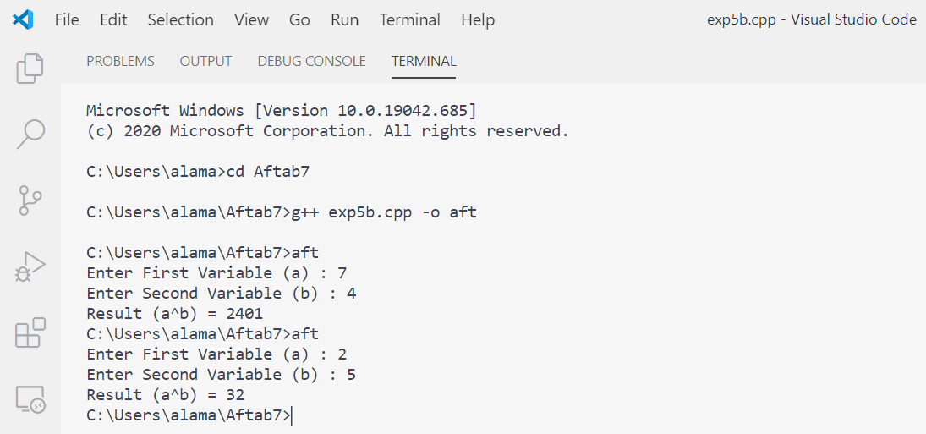

**Define/Use Table :**

|  |  |  |  |
| --- | --- | --- | --- |
| **S. No.** | **Variable** | **Defined at Node** | **Used at Node** |
| 1 | a | 3 | 5,8 |
| 2 | b | 3 | 7,8 |
| 3 | result | 3,8 | 9 |

**Du Path Table :**

|  |  |  |
| --- | --- | --- |
| **S. No.** | **Variable** | **Du Path (Begin, End)** |
| 1 | a | 3,5 3,8 |
| 2 | b | 3,7 3,8 |
| 3 | result | 3,9 8,9 |

**All uses definition clear :**

|  |  |  |  |
| --- | --- | --- | --- |
| **S. No.** | **Variable** | **Du Path (Begin, End)** | **Definition clear?** |
| 1 | a | 3,5 | Yes |
| 2 | a | 3,5,8 | Yes |
| 3 | b | 3,7 | Yes |
| 4 | b | 3,7,8 | Yes |
| 5 | result | 3,8,9 | No |
| 6 | result | 8,9 | Yes |

There is a total of 6 du-paths out of which 1 path is not defined clearly.

**Test case table of all users :**

|  |  |  |  |  |  |
| --- | --- | --- | --- | --- | --- |
| **S. No.** | **Variables** | | | **Expected Output** | **Du Path** |
| **a** | **b** | **result** |
| 1 | 2.5 | 4 | 39.0625 | 39.0625 | 3,5 |
| 2 | 2.5 | 4 | 39.0625 | 39.0625 | 3,5,8 |
| 3 | 4.3 | 5 | 1470.08 | 1470.08 | 3,7 |
| 4 | 4.3 | 5 | 1470.08 | 1470.08 | 3,7,8 |
| 5 | 5 | 2.2 | 34.4932 | 34.4932 | 8,9 |

**Test case table of all definition :**

|  |  |  |  |  |  |
| --- | --- | --- | --- | --- | --- |
| **S. No.** | **Variables** | | | **Expected Output** | **Du Path** |
| **a** | **b** | **result** |
| 1 | 5 | 2.2 | 34.4932 | 34.4932 | 3,8,9 |